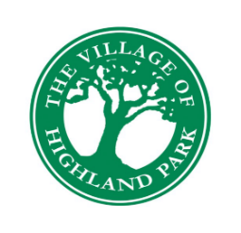**Village of Highland Park, Florida**

**WORK SESSION AGENDA**

**November 1, 2023**

**3:00 p.m.**

Administration Building

1650 Highland Park Drive North

1. Call to Order
2. Roll Call

* Commission Seat 1: Vacant
* Commission Seat 2: Mayor-Commissioner Brandon McWhorter
* Commission Seat 3: Commissioner Amanda Updike

1. Discussion Items

* City Commissioner Seat 1 Appointment
* City Manager Position
* New Business for November 28th Regular Meeting Agenda

1. Public Comments
2. Adjournment

Minutes of Village Commission meetings may be obtained from the Village Clerk’s Office. The minutes are recorded, but not transcribed verbatim. Persons requiring a verbatim transcript may make arrangements with the Clerk to duplicate the recording. The cost of duplication will be the expense of the requesting party.

In accordance with Section 286.26, Florida Statutes, persons with disabilities needing special accommodations to participate in this meeting should contact the Village Clerk’s Office no later than 5:00 p.m. on the day prior to the meeting at 863-455-6518, or via email at clerk@highlandpark-fl.org.

Appeals concerning decisions on issues requiring a public hearing:

Persons who wish to appeal any decision made by the Village Commission with respect to any matter considered during a public hearing at this meeting will need a record of the proceedings, and for such purpose may need to ensure that verbatim record of the proceedings is made, which record includes the testimony and evidence upon which the appeal is based.