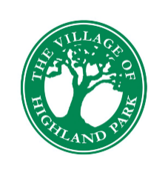
VILLAGE OF HIGHLAND PARK
1650 Highland Park Drive North
Wednesday, July 23, 2025
6:00 p.m.
REGULAR MEETING AGENDA

Call to Order by Mayor Brandon McWhorter
Pledge of Allegiance led by Mayor Brandon McWhorter
Roll Call by Lita O’Neill, Assistant to the Clerk
Consent Agenda
- Adoption of Previous Meeting Minutes for May 28, 2025
City Manager’s Report
Treasurer’s Report
Commission Regular Agenda
- Ordinance 2025-01 (Village-initiated Rezoning)
- Second Reading of Ordinance 2025-01
- Public Hearing
- Resolution 2025-01 Preliminary Rate Resolution for Non-Ad Valorem Fire Assessment
Recognition of Citizens Please Limit Your Comments to 5 Minutes.
Questions/Comments/Announcements from the Village Commissioners
- The next meeting of the Village Commission will be a special meeting on August 27, 2025, at 6:00 pm, at such time Resolution 2025-02 Final Rate Resolution for Non-Ad Valorem Fire Assessment will be considered.
Adjourn
Minutes of Village Commission meetings may be obtained from the Village Clerk’s Office. The minutes are recorded, but not transcribed verbatim. Persons requiring a verbatim transcript may make arrangements with the Clerk to duplicate the recording. The cost of duplication will be the expense of the requesting party. In accordance with Section 286.26, Florida Statutes, persons with disabilities needing special accommodations to participate in this meeting should contact the Village Clerk’s Office no later than 5:00 p.m. on the day prior to the meeting at 863-455-6518, or via email at clerk@highlandpark-fl.org.

